# Reuse and render a xib in a storyboard.

# 1． Create a new UIView named 'DesignableXibView'

File > New > File > Source > Cocoa Touch Class > UIView

# 2．Create a matching xib file named 'DesignableXibView'

File > New > File > User Interface > View

3．Set the file owner of the of the xib

select the xib

select file's owner

set custom class to 'DesignableXibView' in the Identity Inspector.

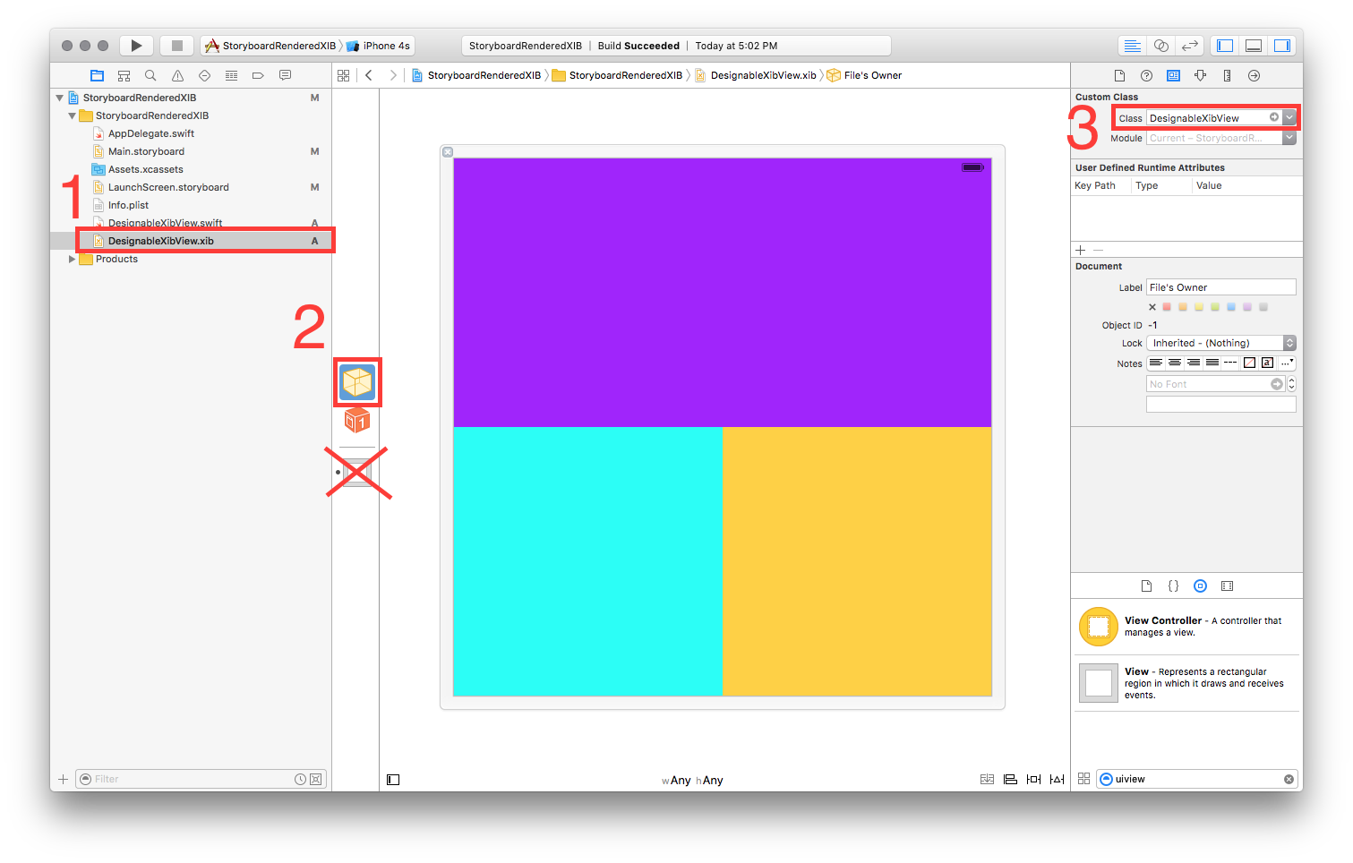

* *Note: Do not set the custom class of the view on the xib. Only the File Owner!*

4．DesignableXibView's Implementation

// DesignableXibView.swift

import UIKit

@IBDesignable

class DesignableXibView: UIView {

var contentView : UIView?

override init(frame: CGRect) {

super.init(frame: frame)

xibSetup()

}

required init?(coder aDecoder: NSCoder) {

super.init(coder: aDecoder)

xibSetup()

}

func xibSetup() {

contentView = loadViewFromNib()

// use bounds not frame or it'll be offset

contentView!.frame = bounds

// Make the view stretch with containing view

contentView!.autoresizingMask = [UIViewAutoresizing.FlexibleWidth, UIViewAutoresizing.FlexibleHeight]

// Adding custom subview on top of our view (over any custom drawing > see note below)

addSubview(contentView!)

}

func loadViewFromNib() -> UIView! {

let bundle = NSBundle(forClass: self.dynamicType)

let nib = UINib(nibName: String(self.dynamicType), bundle: bundle)

let view = nib.instantiateWithOwner(self, options: nil)[0] as! UIView

return view

}

}

5．Test your reuseable view in a storyboard

Open your storyboard

Add a view, set it’s constraints

Add a subview into the above view.

Set that view's Custom Class

*wait a sec ...* BOOM!!